INDRODUCTION

Overview

Electricity, phenomenon associated with stationary or moving electric charges. Electric charge is a fundamental property of matter and is borne by elementary particles. In electricity the particle involved is the electron, which carries a charge designated, by convention, as negative.

Purpose

People use electricity for lighting, heating, cooling, and refrigeration and for operating appliances, computers, electronics, machinery, and public transportation systems.

Most electricity is generated with steam turbines using fossil fuels, nuclear, biomass, geothermal, and solar thermal energy. Other major electricity generation technologies include gas turbines, hydro turbines, wind turbines, and solar photovoltaics.

PROBLEM DEFINITION & DESIGN THINKING

Empathy map

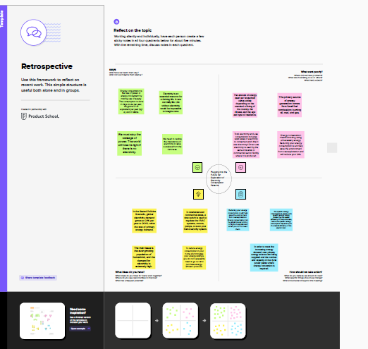

Brainstorm

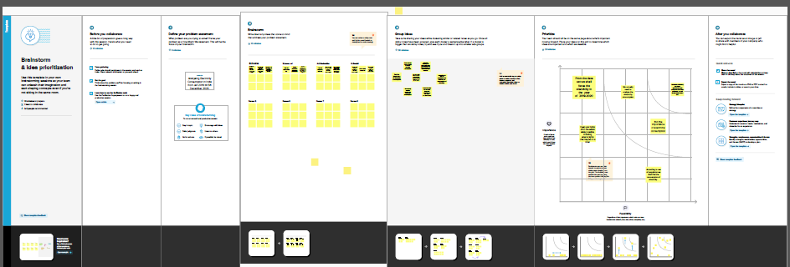

RESULT

Social Impact:

By providing access to electricity, the analysis can help to improve the quality of life for people living in areas without access to electricity, including providing access to lighting, heating, and cooling, and powering essential services such as hospitals and schools..

Business Model/Impact:

By understanding consumption patterns and trends, the

analysis can help businesses identify market opportunities and develop strategies to meet the growing demand for electricity in India.

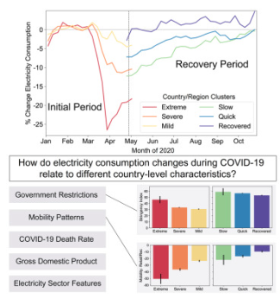

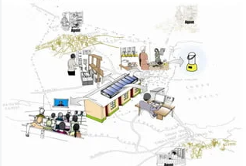

ADVANTAGES

The advantage of electric power is its reliable and uninterrupted supply runs the equipment efficiently and continuously.

The transportation of electricity is easy once the transmission lines are functional. They work for years and need no or very less maintenance.

DISADVANTAGES

*Power plants that are used in the production of electricity burn biomass in order to produce sulfur dioxide and nitrogen oxides. *These are two major pollutants that harm the environment.

*A lot of radioactive material is released that can be lethal to humans and other organisms.

*Carbon dioxide gas is a substance that causes global climate change.

APPLICATION

People use electricity for lighting, heating, cooling, and refrigeration and for operating appliances, computers, electronics, machinery, and public transportation systems.

CONCLUSION

Current through a given area of a conductor is the net charge that passes per unit time through the conductor. To keep up a gradual current, we must have a circuit within which an electrical phenomenon occurs from lower to higher mechanical energy.

FUTURE SCOPE

This target comprises of 1155.200 BU Thermal; 149.544 BU Hydro; 43.020 Nuclear; and 8.236 BU Import from Bhutan. Share of non-fossil fuel-based generation capacity in the total installed capacity of the Country likely to increase from 42% as of October 2022 to more than 64% by 2029-30.

APPENDIX

Source code - dashboard

<div class='tableauPlaceholder' id='viz1682289916370' style='position: relative'><noscript><a href='#'><img alt=' ' src='https:&#47;&#47;public.tableau.com&#47;static&#47;images&#47;Da&#47;Dashboard_16823191869940&#47;Dashboard3&#47;1_rss.png' style='border: none' /></a></noscript><object class='tableauViz' style='display:none;'><param name='host_url' value='https%3A%2F%2Fpublic.tableau.com%2F' /> <param name='embed_code_version' value='3' /> <param name='site_root' value='' /><param name='name' value='Dashboard_16823191869940&#47;Dashboard3' /><param name='tabs' value='no' /><param name='toolbar' value='yes' /><param name='static_image' value='https:&#47;&#47;public.tableau.com&#47;static&#47;images&#47;Da&#47;Dashboard_16823191869940&#47;Dashboard3&#47;1.png' /> <param name='animate_transition' value='yes' /><param name='display_static_image' value='yes' /><param name='display_spinner' value='yes' /><param name='display_overlay' value='yes' /><param name='display_count' value='yes' /><param name='language' value='en-US' /></object></div> <script type='text/javascript'> var divElement = document.getElementById('viz1682289916370'); var vizElement = divElement.getElementsByTagName('object')[0]; if ( divElement.offsetWidth > 800 ) { vizElement.style.width='100%';vizElement.style.height=(divElement.offsetWidth*0.75)+'px';} else if ( divElement.offsetWidth > 500 ) { vizElement.style.width='100%';vizElement.style.height=(divElement.offsetWidth*0.75)+'px';} else { vizElement.style.width='100%';vizElement.style.height='1477px';} var scriptElement = document.createElement('script'); scriptElement.src = 'https://public.tableau.com/javascripts/api/viz_v1.js'; vizElement.parentNode.insertBefore(scriptElement, vizElement); </script>

Source code – story

<div class='tableauPlaceholder' id='viz1682290409561' style='position: relative'><noscript><a href='#'><img alt='Story on electricity consumption in india ' src='https:&#47;&#47;public.tableau.com&#47;static&#47;images&#47;Bo&#47;Book2____&#47;Story1&#47;1_rss.png' style='border: none' /></a></noscript><object class='tableauViz' style='display:none;'><param name='host_url' value='https%3A%2F%2Fpublic.tableau.com%2F' /> <param name='embed_code_version' value='3' /> <param name='site_root' value='' /><param name='name' value='Book2____&#47;Story1' /><param name='tabs' value='no' /><param name='toolbar' value='yes' /><param name='static_image' value='https:&#47;&#47;public.tableau.com&#47;static&#47;images&#47;Bo&#47;Book2____&#47;Story1&#47;1.png' /> <param name='animate_transition' value='yes' /><param name='display_static_image' value='yes' /><param name='display_spinner' value='yes' /><param name='display_overlay' value='yes' /><param name='display_count' value='yes' /><param name='language' value='en-US' /></object></div> <script type='text/javascript'> var divElement = document.getElementById('viz1682290409561'); var vizElement = divElement.getElementsByTagName('object')[0]; vizElement.style.width='100%';vizElement.style.height=(divElement.offsetWidth*0.75)+'px'; var scriptElement = document.createElement('script'); scriptElement.src = 'https://public.tableau.com/javascripts/api/viz_v1.js'; vizElement.parentNode.insertBefore(scriptElement, vizElement); </script>